Database System Engineering and Distributed Backend Development
Course Code: 25CS13002E
ROLL NO:2520030233
NAME: K.Akshitha Reddy
Query 1: Create Data Base
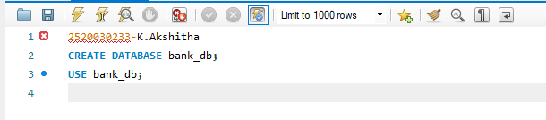
Output:
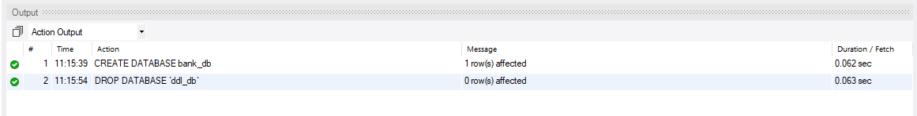
Query 2:CREATE TABLE
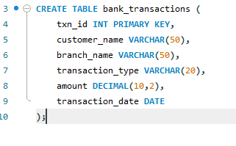
OUTPUT:
Query 3: ALTER TABLE ADD COLUMN
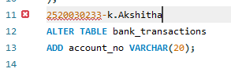
Output:
Query 4: ALTER TABLE MODIFY COLUMN
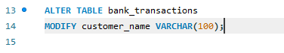
Output:
Query 5: RENAME TABLE
Output:
Query 6: TRUNCATE TABLE
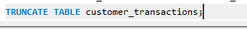
OUTPUT:
Query 7: DROP TABLE

SECTION 2 : DML (DATA MANIPULATION LANGUAGE)

Query 8: INSERT SAMPLE DATA
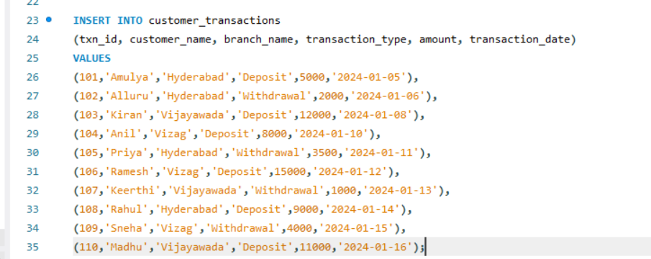
Output:

Query 9: UPDATE
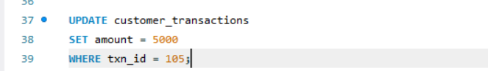
Output:

Query 10: DELETE
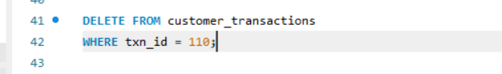
Output:

Query 11: SELECT
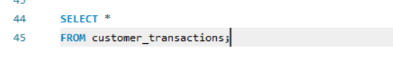
Output:
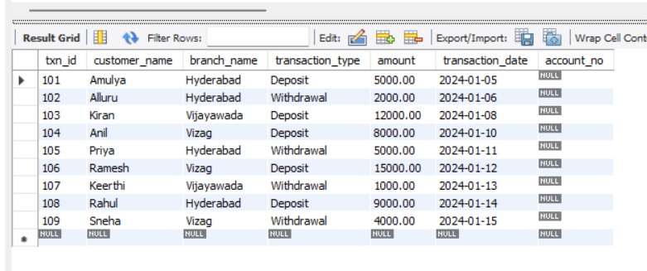

Query 12: SELECT WITH WHERE
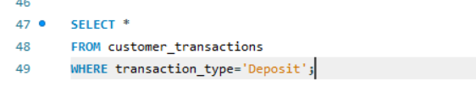
Output:
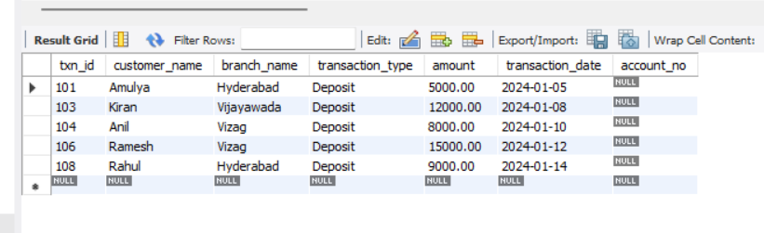

Query 13: SELECT WITH ORDER BY
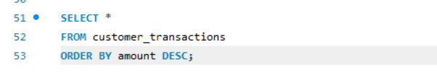
Output:
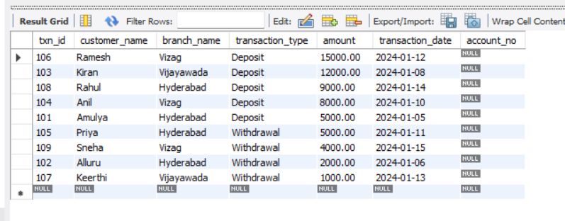
SECTION 3 : DCL (DATA CONTROL LANGUAGE):
Query 14: GRANT SELECT
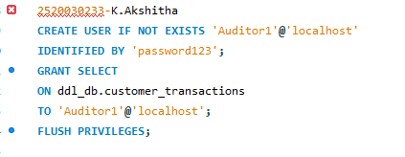
Output:
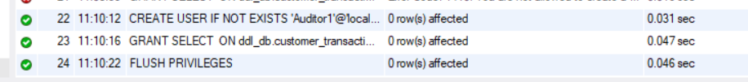

Query 15: GRANT ALL PRIVILEGES
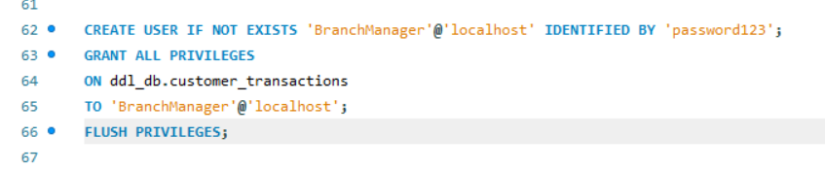
Output:
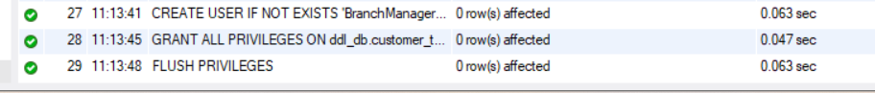

Query 16: REVOKE SELECT
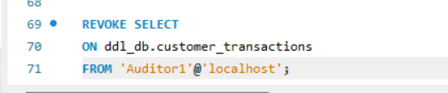
Output:

Query 17: REVOKE ALL
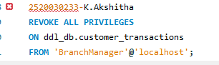
Output:

SECTION 4 : TCL (TRANSACTION CONTROL LANGUAGE)
Query 18: COMMIT
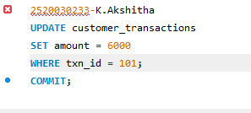
Output:

Query 19: SAVEPOINT
Output:
Query 20: ROLLBACK TO SAVEPOINT
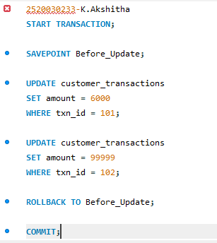
Output:
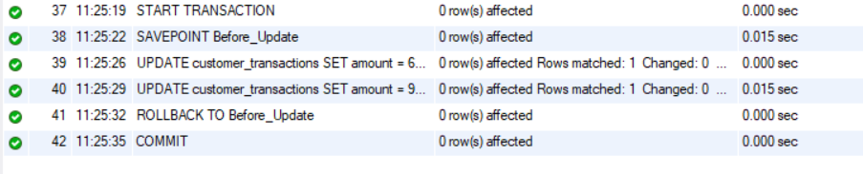
Query 19: SAVEPOINT
Output:

Query 20: ROLLBACK TO SAVEPOINT

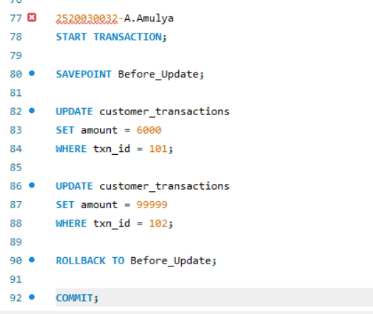
Output:

